

There are several ways of searching for a patient:

* **Demographic Search** – Use patients NHI, Name and/or date of birth to search.
* **Current Inpatient Search** – Generate a list of current inpatients. You can filter by Clinician, Facility, Speciality or Location.
* **Outpatient Search** - Generate a list of outpatients. You can filter by Clinician, Clinic, Speciality, DHB & date.
* **ED Patient List** – Shows all patients that are or have been in ED today.
* **Recent Patients** – The Recent Patients list is automatically populated with the names of the last 50 patients you have viewed.

**Patient Searches & Lists**

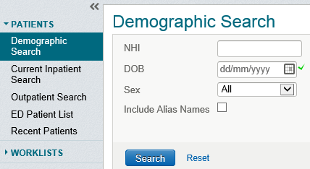

**Clinical Document Viewer aka CDV Tree**

The CDV Tree holds all clinical documents and correspondence, discharge summaries, lab and radiology results.

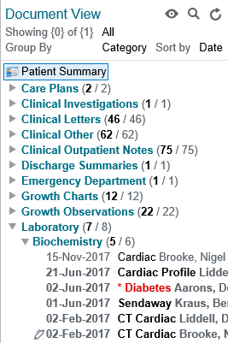

 Choose how you wish to view information in the CDV Tree:

**Show:** All, or specific range

**Group By:** Category, Date, Service or Author

**Sort By:** Date, Title or Author

 Search the CDV Tree

 Takes you back to the original layout

Pen icon indicates unsigned results.



**Clinical Portal Tips**

* Work from Lists – Favourite Searches, Worklists, Recent Patients
* Use the arrows  to move between patients or click the 3 lines in the middle to display a list of recent patients
* Configure your home page display. Add/remove windowlets where you prefer to see them
* Personalise user settings to best suit your workflow Align yourself to a ward, clinician etc.

**Note:** Not all functionality is currently available due to limited access of the view only role

V1.0 28-5-18

**How to interpret results in the CDV Tree**

|  |  |  |  |
| --- | --- | --- | --- |
| Item | Item | Style | Example |
| Documents | Read/Unread document count | (xx unread/xx total results) |  |
| Interim document | Italics |  |
| Final document (unread) | Bold font |  |
| Final document (read) | Normal font |  |
| Lab reports | Interim lab report | Item name in Italics |  |
| Final lab report (read) | Normal font |  |
| Abnormal lab report (unread) | Report name in red font bold, date and author in light grey bold.  One asterisk before report name |  |
| Abnormal lab report (read) | Report name in red font, date, author in light grey.  One asterisk before report name |  |
| Interpreting lab report | Unread | Report name in blue font, date and author in light grey |  |
| Read | Report name in blue font, date and author in light grey |  |
| Abnormal | Report name in red font, date and author in light grey.  One asterisk before report name |  |

**More Information:**

If you have any questions please email [clinicalportal@hawkesbaydhb.govt.nz](mailto:clinicalportal@hawkesbaydhb.govt.nz), we are more than happy to help.

*Visit the Clinical Portal homepage on* ***Our Hub*** *under* ***Our Place.***