6.4 Demographics Tab
The demographic tab in CP will display demographic information from ECA. This information will continue to be updated in ECA, which will update Clinical Portal in real time.
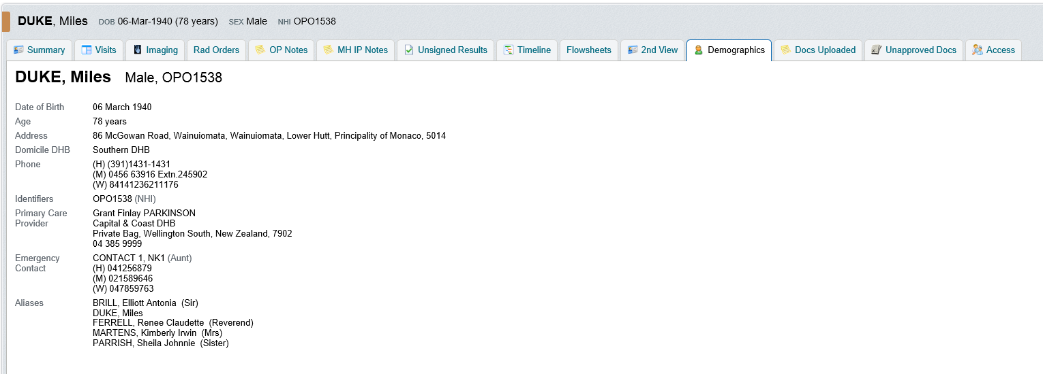
Differences to note:
- All aliases will be listed in the demographic tab under Aliases and if the patient’s NHI has been merged, the minor NHI number(s) will display under Identifiers.

- Only one emergency contact will display in CP. This information and any other emergency contacts will still be displayed in ECA.

- Ethnicity, Marital Status, Occupation and Type of Residency do not display in CP, although this information will still be accessible in ECA.

- Due to Clinical Portal being a regional application; if a patient’s NHI is in the process of being merged, the demographic information in CP could differ from ECA, however, a warning will display when the patient’s record is opened in ECA.

