[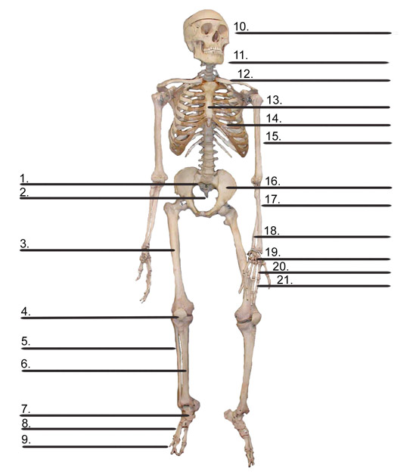](http://www.google.com/url?sa=i&rct=j&q=&esrc=s&source=images&cd=&cad=rja&uact=8&ved=0ahUKEwjO2ozUrZLZAhVFErwKHcb2A7gQjRwIBw&url=http%3A%2F%2Fwww.cybersurgeons.net%2Fresources%2F%3F%2Fskeletalsys%2F177%2F&psig=AOvVaw2ZwugU5T6k6TqvtbQeQMsg&ust=1518043112346157)