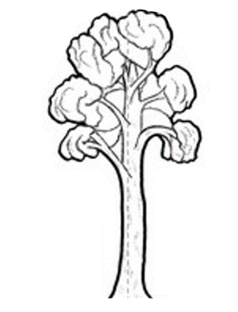
CHILD HEALTH TEAM
Ngā Kura Hauora

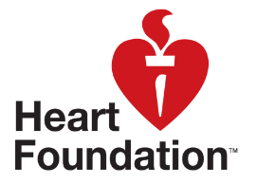

Ngā Kahikatea

Newsletter Messages August 2019
Each month we offer a selection of messages that you can copy / use / edit / re-style and include in your school newsletter. The idea is to support the work that you are doing in the classroom and on the playing field with positive messages that are going home.
Kids in the Kitchen
Many children love to learn in the kitchen and they are always so proud of their results. One way to encourage your kids in the kitchen is to use cooking videos that show you exactly what to do. It’s even better if they make tasty, healthy kai. A great place to look for ideas is the website of the Heart Foundation. They have plenty of recipe videos like this one.
https://www.heartfoundation.org.nz/educators/edu-resources/chicken-soup-video

Science for Health & Wellbeing
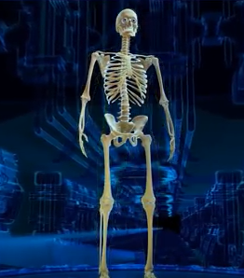
It’s great when we see our students out running, jumping and playing. It’s part of a learning journey that includes finding out how our bodies work and how we can best look after them. Here’s a link to a short video that you and your children might enjoy: https://www.youtube.com/watch?v=AMxIv1i33mI

Sleep

Why sleep is important
Sleep is important for restoring energy and helping children grow and develop.
More and more evidence suggests that not enough or poor quality sleep can have a negative effect on a child’s behaviour, learning, health, wellbeing and weight.

How much sleep your child needs in 24 hours
The table below shows the recommended total hours of sleep per day for children and young people. Some children naturally sleep slightly less or more than these recommended hours.
Age | Recommended (hours)
School age (5–13 years) | 9–11
Teenagers (14–17 years) | 8–10
Young adults (18–25 years) | 7–9

Ways to improve your child’s sleep

Bedtime routine
- Have a regular bedtime routine: this might include your child having a shower, brushing their teeth, then going to bed. Quiet activities, like reading, are good before bed.
- Have a regular bedtime and wake up time. This will help your child understand when it is time to sleep.
- If your child is going to bed too late, gradually change this by having them go to bed 30 minutes earlier and get up 30 minutes earlier.
- Avoid active games, playing outside, and screen use (eg, TV, internet, computer games, etc) in the hour before bedtime. Try dimming the lights earlier.

Sleeping environment
- Arrange a comfortable sleeping environment for your child. The place where they sleep should be quiet, warm and dark (although a night light is OK).
- Don’t have any distractions within sight or hearing of the area where children sleep, including TV or any kind of computer screen.

Food
- Avoid having your child eat a meal within 1 or 2 hours of going to sleep. However, a light snack or a milky drink may help some children.
- Avoid giving your child food and any drinks that contain caffeine (especially in the afternoon/evening) as this can affect their sleep.

Ideas from Overseas
Here in NZ we are always looking for ways to feed our children with good kai that doesn’t break the bank. And it turns out that we’re not alone. Here’s some thoughts from Canada’s Food Guide.
https://food-guide.canada.ca/en/tips-for-healthy-eating/healthy-eating-on-a-budget/
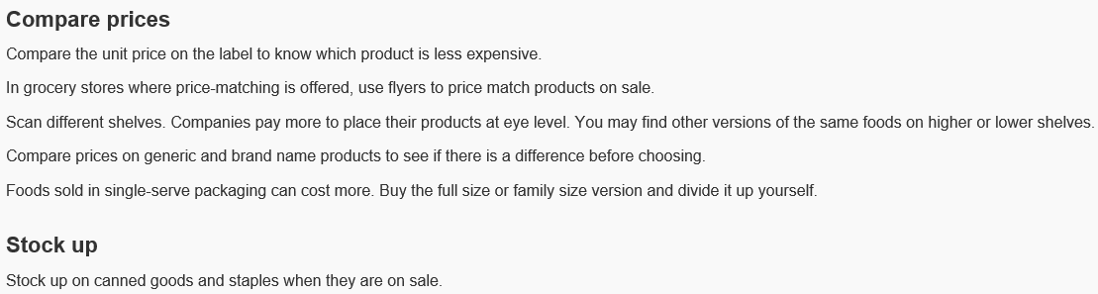
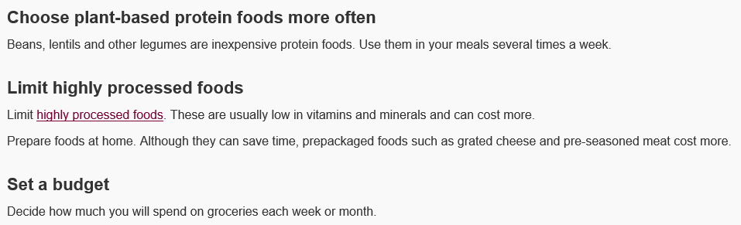

Fundamental Movement Skills
Children and adults all need to practice their fundamental movement skills (pictured here). We work with these in mind in the games we play at school – get your child to show you the skills that they have. And to explain what they’ll need them for.

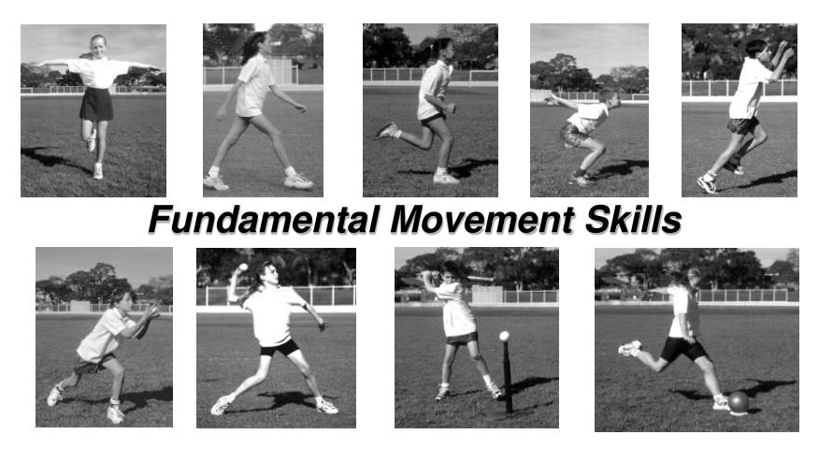
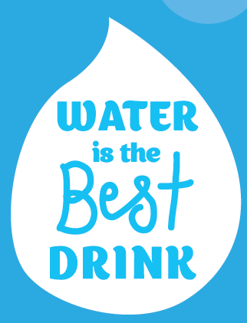
Water Only at School
Research has shown that poor nutrition can be associated with lower academic achievement and poor school attendance. Creating a school environment that promotes and supports healthy choices is one way that schools can help students reach their potential.

This is why the Ministries of Education and Health are encouraging all schools to become water-only. Being water-only means making sure that water (and plain milk) is the only drink in school. When we choose water, it means we’re not drinking sugary drinks which contribute to many preventable health conditions like obesity, tooth decay and type 2 diabetes.
Research by the Health Promotion Agency found that 93% of parents and caregivers think it is important for schools to limit access to sugary drinks. Schools that have moved to being water-only have seen that it benefits teaching and learning as well as student health and wellbeing.

“Ngā Kahikatea” – a tree endemic to NZ that was previously widespread on the Heretaunga Plains. The tree is associated with concepts of standing tall and straight whilst mutually supporting one another at the roots. Like our tamariki in their communities and schools.

